*#TASK2*

def isperfect(*n*):

    sum=0

*for* i *in* range(1,*n*):

*if* *n* % i==0:

            sum=sum+i

*if* sum==*n*:

*return* True

*return* False

n=6

print(isperfect(n))

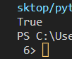

*#TASK3*

def ispalindrome(*string*):

    new_str = ""

*for* i *in* *string*:

        new_str = i + new_str

*if* *string*==new_str:

*return* True

*else*:

*return* False

n="jadaj"

print(ispalindrome(n))

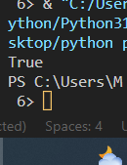

*# Task1*

def reverse_str(*string*):

    new_str = ""

*for* i *in* *string*:

        new_str = i + new_str

*return* new_str

n="Pakistan"

print(reverse_str(n))

